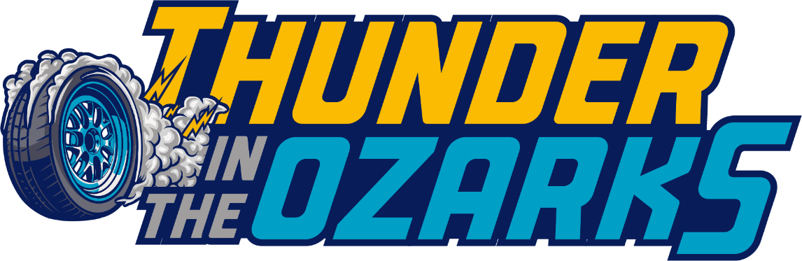

5th Annual Vintage Festival
Presented by the Vintage Sports Car Drivers Association (VSCDA)
October 9–11, 2026
Ozarks International Raceway – Gravois Mills, Missouri
The Vintage Sports Car Drivers Association returns to Ozarks International Raceway for the 5th Annual Thunder in the Ozarks Vintage Festival, three unforgettable days celebrating the heritage, spirit, and camaraderie of vintage racing.
Set against the stunning backdrop of the Missouri Ozarks, this event showcases some of the most beautiful and historically significant race cars ever built, competing on one of the most exciting modern road courses in America. Drivers and enthusiasts will come together to celebrate the enduring passion that fuels the vintage racing community.
At the heart of the event is the spectacular 3.97-mile Ozarks International Raceway, a world-class circuit featuring 19 challenging turns and nearly 1,200 feet of elevation change per lap. This highly technical course rewards drivers’ skill while delivering exceptional racing action for spectators.
True to the VSCDA tradition, Thunder in the Ozarks places a strong emphasis on maximum track time and well-balanced race groups, ensuring competitors enjoy ample seat time while maintaining the club’s long-standing commitment to safe, respectful competition.
As always, the experience extends well beyond the track. One of the hallmarks of VSCDA events is the sense of community that brings racers together year after year. Catered dinners on Friday and Saturday evenings, held right in the garage area, provide the perfect setting for sharing stories, reliving the day’s racing, and building the friendships that make vintage racing unique.
Throughout the weekend, drivers and crew will enjoy on-site food trucks offering a variety of dining options, plentiful paved paddock parking, and a limited number of rentable garages.
Whether you are a seasoned vintage racer, a newcomer eager for your first laps, or a fan of classic motorsport, Thunder in the Ozarks promises a weekend filled with spirited driving, great company, and the unmistakable joy of vintage racing.
Join us in October and experience why Thunder in the Ozarks has quickly become one of the most anticipated events on the VSCDA calendar.

3 Day Races Fri-Sun (2 Crew)
Early bird through 10/2/2026 $585
After 10/2/2026 $685

Thursday Test & Tune Day $275

VSCDA Temporary Membership $ 80
(All drivers must be VSCDA members)

Co-Driver $100

Additional Car $150

Additional Crew $ 20

Garage Rental – $ 65/single car space
100 spaces available for 2 car double occupancy – Team up with your buddy or meet a new friend.

Saturday & Sunday Touring $ 35/Day

Friday Night Dinner (1 free w/entry) $ 35
(Two Drink Tickets Included)

Saturday Night Dinner (1 free w/entry) $ 35
(Two Drink Tickets Included)
Cancellation Refund Policy: A full refund of the entry fee will be issued before September 24, 2026. A partial refund (entry fee - $50.00 service fee) will be issued until the opening of registration Thursday p.m. No refunds for cancellations will be made once registration closes on track entrance day (the day before the 1st practice race begins).

Additional
Hotels - For a full list of lodging options go to https://www.funlake.com/lodging

Camping - RV Spots - 12 with 30-amp connections – 12 with 50-amp connection. Reserve at services@ozarksinternationalraceway.com

Fuel – Race fuel is available at the service building.

